* Full name: Iván Kaleb Ramírez Torres
* NAO ID: 3357
* Date: September 9th, 2025
* Name of the pathway in which you are enrolled: Bécalos Teho Ready
* Title of the Challenge: **Develop – Screenshot report**

## Table of Contents

|  |  |
| --- | --- |
| Screenshot | Content |
| 1 | Repository creation in GitHub and project upload |
| 2 | New branch creation |
| 3 & 4 | Update to the requirements.txt file |
| 5, 6 & 7 | Created PR |
| 8 & 9 | PR approval in GitHub |

## Screenshots

### Repository creation in GitHub and project upload

Creation of repository “Sprint2” with project file already uploaded. This file was added from GitHub webpage, and a markdown file was added for brief description of repository.

### New branch creation

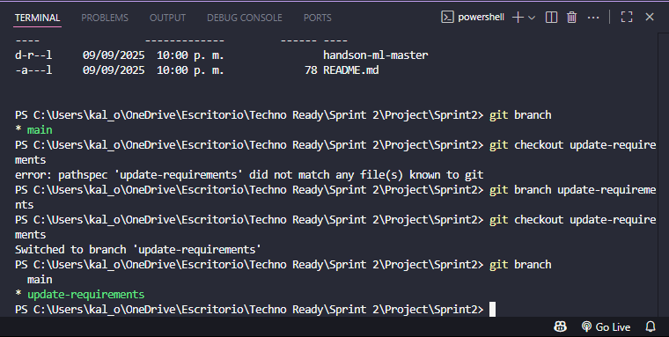

From git bash, a new branch named “update-requirements” was created.   
Making sure we move from the main to the new branch with “git checkout” and coroborating with git branch.

3 & 4. Update to the requirements.txt file

Requirements.txt file was modified adding a few sentences at the end of the file.

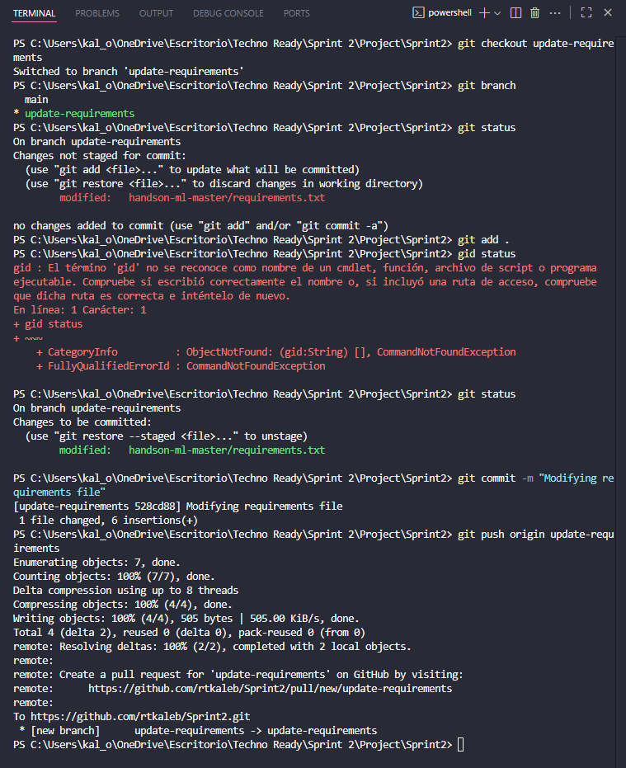

After modification, the file changed was added to the commit with “git add” and then it was committed with “git commit”. After this, it was pushed to the GitHub repository creating a new branch for web repository named “update-requirements” (Same name as in the local repository) with “git push origin update-requirements”.

5, 6 & 7. Created PR

After making push origin and creating a new branch in GitHub repository, the pull request option appeared on web repository.

Then the PR appeared to be evaluated.

### 8 &9 PR approval in GitHub Interfaz de usuario gráfica, Texto, Aplicación, Correo electrónico El contenido generado por IA puede ser incorrecto.From here it was pretty easy to just approve the PR for merging the files in the main branch.

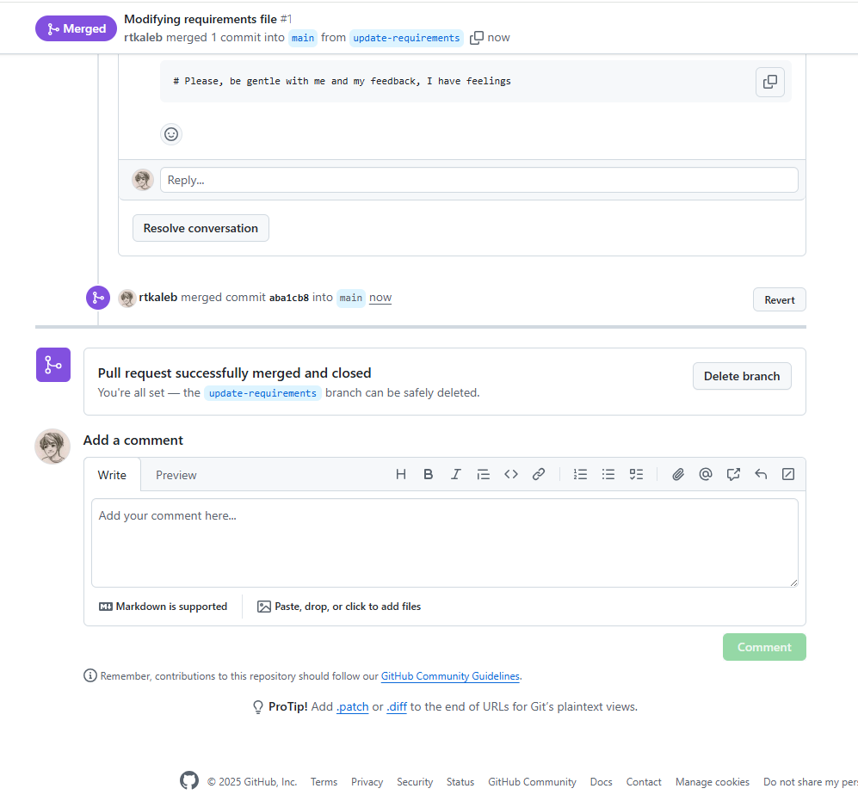 This SS is from the merging to the main branch.